Name: ………………… Date : ..........................................................................
ENGLISH EVALUATION : physical description and clothes

1) Write a cross if you hear words about physical description :
1 | 2 | 3 | 4 | 5 | 6 | 7 | 8 | 9 | 10
 | x |  | x | x |  |  | x | x
2) Write a cross if you hear words about clothes:
1 | 2 | 3 | 4 | 5 | 6 | 7 | 8 | 9 | 10
 | x | x |  |  | x | x |  | x | x
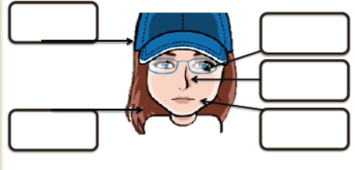
head
3) Complete with good words.
eyes
nose
mouth
hair
neck
shoulder

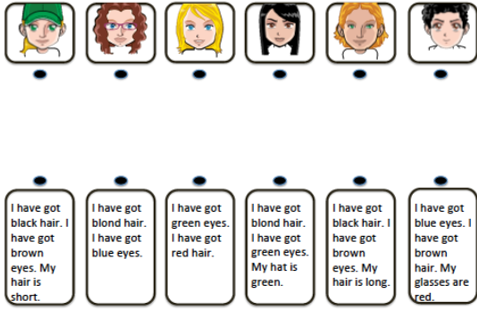
4) Read and match:

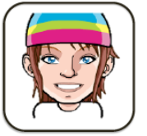
5) Write a description for example
She has blue yes, a longue nose and big ears.
She has straight and short hair.
She has a big mouth and thin lips.
She wears a pink, green, and blue hat.

6) Color and describe your monster: arm, eyes, finger, hand, legs toes, head,
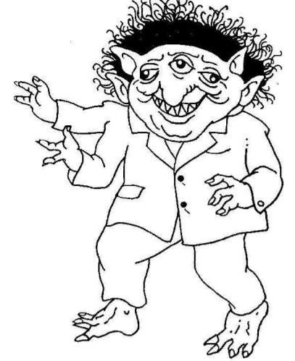
ears, hair, nose, mouth, feet

6) Read and draw :
She is tall and plum.
She has got blue eyes, a long nose, a big mouth with thick lips, small ears and curly dark hair.
She wears a red skirt, a green pullover, a grey scarf, brown gloves, black shoes and a purple hat.

7) Write in English: Retire ton manteau bleu. Take off your blue coat.
Enlevez vos chaussures. Take off your shoes.
Il porte son pullover rouge. He wears his red pullover.

8) Translate in French: What can you wear in summer? Que pouvons –nous porter en été ?
May I wear your clothes today? Puis-je porter tes vêtements aujourd’hui?

